SBStopTM
Installation & User's Guide (2.1v)

Installation of SBStopTM on Snowboard and boot. www.sbstop.com
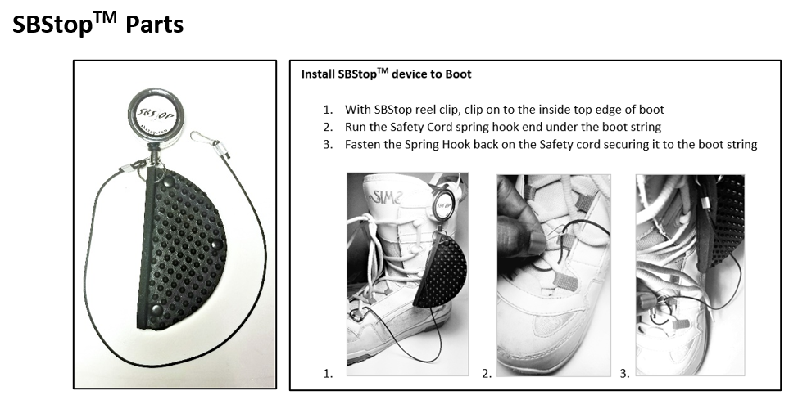
How to Use SBStopTM (5 Steps – see Fig. 1)

A Few Things First:
- Snowboard position when starting for Right feet Front snowboarder (goofy) - The front of your snowboard should be pointed down slope when you start off at a 1 o’clock position (where 12 o’clock is straight down the slope). For Left Feet Front board placement would be at 11 o’clock.
- The incline of the snow at your starting point should be gradual and not too steep. This allows the SBStopTM pad to keep you from sliding while you mount your free boot.
  - Fig. 2 shows the 3 different placements of the SBStopTM pad: 1) Along the edge for near flat inclines, and 2) Face down and 3) Face up, both for slightly steeper inclines. (pad can be placed completely under the board edge to maximize grip and friction).
Steps:
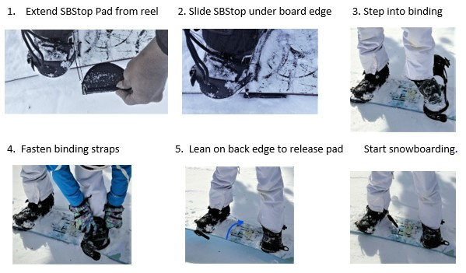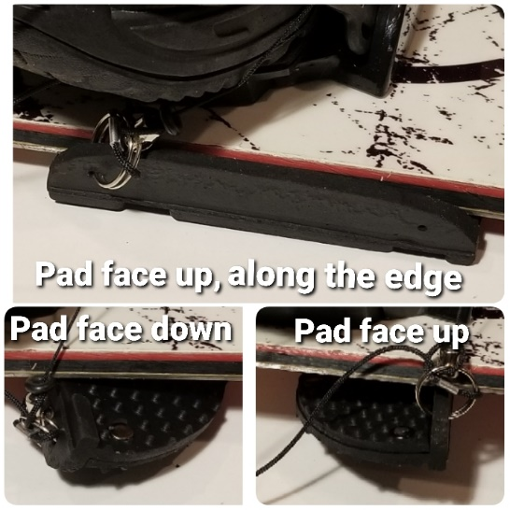
Fig. 1 Fig. 2

