SBStopTM
Installation & User's Guide (1.7v)

Installation of SBStopTM on Snowboard and boot. www.sbstop.com

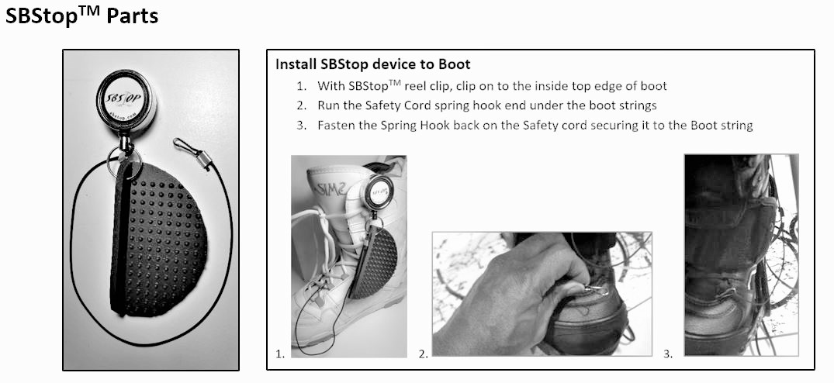

How to Use SBStopTM (4 Steps)

A Few Things First:
- Snowboard position when starting for Right feet Front snowboarder (goofy) - The front of your snowboard should be pointed down slope when you start off at a 1 o’clock position (where 12 o’clock is straight down the slope. For Left Feet Front borad placement would be at 11 o’clock
- The incline of the snow at your starting point should be gradual and not too steep. This allows the SBSTOP pad to keep you from moving while you mount your open boot.

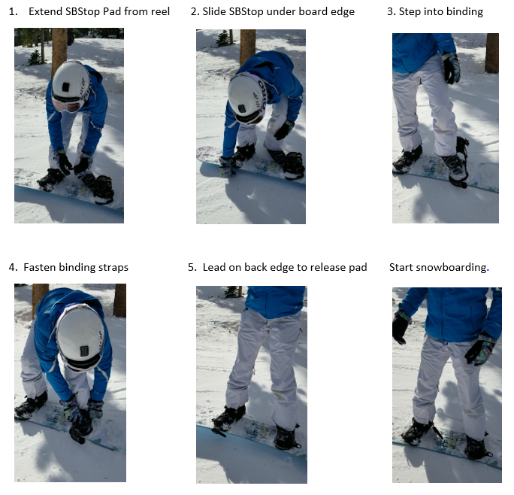
Steps:

